**Software Requirements Specification**

**for**

Human Resource Management System

**Version 1.0 approved**

**Prepared by Group 16**

**September 09, 2023**

| **Group Members** | |
| --- | --- |
| **Perera S.A.I.M.** | **210471F** |
| **Thabendra S.** | **210627P** |
| **Fernando P.P.D.** | **210163M** |
| **Laksara K.Y.** | **210329E** |
| **Akshiya R.** | **210025T** |

**Table of Contents**

**Table of Contents ii**

**Revision History iii**

**1. Introduction 1**

1.1 Purpose 1

1.2 Document Conventions 1

1.3 Intended Audience and Reading Suggestions 1

1.4 Product Scope 1

1.5 References 2

**2. Overall Description 3**

2.1 Product Perspective 3

2.2 Product Functions 4

2.3 User Classes and Characteristics 5

2.4 Operating Environment 6

2.5 Design and Implementation Constraints 6

2.6 User Documentation 7

2.7 Assumptions and Dependencies 7

**3. External Interface Requirements 8**

3.1 User Interfaces 8

3.2 Hardware Interfaces 12

3.3 Software Interfaces 13

3.4 Communications Interfaces 13

**4. System Features 14**

4.1 Login 14

4.2 Create new user 14

4.3 View Personal Information of the Employee 15

4.4 Edit Personal Information 16

4.5 Request Leave 17

4.6 Approve/Decline Leave 17

4.7 Generate Reports 18

4.8 Customize Leave Allowances 18

4.9 Change Table Attributes 19

**5. Other Nonfunctional Requirements 20**

5.1 Performance Requirements 20

5.2 Safety Requirements 20

5.3 Security Requirements 20

5.4 Software Quality Attributes 20

5.5 Business Rules 20

**6. Other Requirements 22**

6.1 Database Requirements 22

6.2 Legal Requirements 22

6.3 Data Backup and Recovery 22

**Appendix A: Glossary 23**

**Appendix B: Analysis Models 24**

1. ER - Diagram 24
2. Use Case Diagram 25

**Revision History**

| **Name** | **Date** | **Reason For Changes** | **Version** |
| --- | --- | --- | --- |
|  |  |  |  |
|  |  |  |  |

# **Introduction**

## **Purpose**

The Jupiter Apparels Company, a multinational company with over 1000 employees, is proposing to construct a human resource management system, which is described in this document.

Three main modules make up the system. The Personal Information Management (PIM) module is primarily used to store copious amounts of personnel data. The report generation module is responsible for producing a comprehensive set of reports as requested by the business, and the absence management module is responsible for managing all the employee leave-related tasks.

This paper details the system's user interfaces, features, and limits as well as explanations of the hardware and software involved.

## **Document Conventions**

The IEEE Software Requirement Specification applies to this document. utilizing bold, italic, and font sizes that adhere to IEEE standard document guidelines.

The font properties in this document were developed in accordance with IEEE standard document guidelines.

## **Intended Audience and Reading Suggestions**

The users of this document include administrators, second management users, HR managers, and other staff members, programmers, project managers, testers, document authors, and other users.

The non-technical users should focus on sections 1-3, and the developers, testers should refer to sections 4 and 5.

## **Product Scope**

According to section 1.1, there are three key components that this human resource management system operates under.

In the initial stages, the system has a user named admin who has full access. The second management user and HR manager can then register as users using the accounts he or she creates. After that, the HR manager can continue to add new personnel to the database. Employee information must also be included in the PIM module; however, employee records can exist without a user. Additionally, using the information from the absence management module, an employee can submit a request for a leave of absence through this system, which the employee's assigned supervisor can either approve or deny. Furthermore, the reporting module has the ability to provide many report formats that business needs.

In order to administer the organization, the company now uses SAP as the ERP, which they intend to replace with a user-friendly HRMS. Thus, by automating the processes for managing personalinformation, managing absences, and producing reports to achieve optimum efficiency, this system aids in the administration of the company's human resources more effectively.

## **References**

IEEE*. IEEE Std 830-1998 IEEE Recommended Practice for Software Requirements Specifications.* IEEE Computer Society, 1998.

# **Overall Description**

## **Product Perspective**

The proposed software system is a web-based application designed to offer a versatile and easily adaptable solution for human resource management (HRM). While existing systems often cater to specific organizations and may have significant differences in their core setup, our system aims to provide a universal solution with essential core functionalities. This approach allows for seamless installation in various organizations while providing the flexibility to customize the interface and features according to each organization's preferences.

The major components of the overall system can be represented as follows:-

| | Organization Information | | --- |      | PIM Module | | --- |  | Absence module | | --- |  | User Management | | --- |  | Customization | | --- |  | Reporting Module | | --- |     **HRM System** |
| --- | --- | --- | --- | --- | --- | --- |

## **Product Functions**

There are four main users in the system:-

**1)** **Administrator User**

* Login/logout the system
* Create accounts for Second Management User and HR Manager
* Request a leave
* Edit table attributes

**2)** **Second Management User**

* Login/logout the system
* Request a leave
* Edit PIM information
* Access to absence related functionalities
* Generate Reports
* Configure Leave allowances

**3) HR Manager**

* Login/logout the system
* Add new normal employee users
* Request a leave
* Edit PIM information
* Generate Reports
* Configure Leave allowances

**4)** **Normal Employee**

* Login/logout the system
* Request a leave

a) Managerial Employee

* Edit PIM information

b) Supervisor

* Approve/reject a leave
* Check details of subordinates

c) Level-1 Employee

* View personal information

## User Classes and Characteristics

There are four main categories of individuals who interact with the system:-

* **Administrators**
  + Each organization has a single administrator.
  + Developers are responsible for creating the administrator account during the product handover.
  + Administrator can establish deputy accounts, which are referred to as Second Management Users and HR Managers.
  + They are responsible for editing table attributes.

* **Second Management Users**
  + The system administrator is responsible for creating Second Management Users.
  + They possess the authority to modify system information, including the personal details of employees within the PIM module.
  + They also can access absence related functionalities.
  + They are able to generate reports.
  + They are able to configure the leave allowances based on the pay grade.

* **HR Managers**
  + HR Managers are created by the system administrator.
  + They have the capability to enroll additional employees as users within the system.
  + They possess the authority to modify the personal details of employees within the PIM module.
  + They are able to generate reports.
  + They are able to configure the leave allowances based on the pay grade.

* **Employees**
  + Employees are the most basic users of the system (Lowest Priority).
  + They can access their own personal information and submit leave requests through the system.
  + Only managerial employees can edit PIM information.
  + Only supervisors can approve or reject a leave and check details of subordinates.

## Operating Environment

This application is a web-based system that functions across various operating systems, and we are considering developing it with cross-platform compatibility. It operates using a client-server architecture. While it can be confined to a Local Area Network (LAN) within an organization's premises upon request, we strongly advocate for web-based usage. This preference arises because many organizations have branches situated in remote areas that require synchronization within the system.

## Design and Implementation Constraints

Application security is contingent on the policies enforced by the cloud service provider.

The application may serve a limited number of clients at the same time because cloud service providers allocate finite resources.

Clients must maintain a stable internet connection since the application primarily operates via the web.

If the implementation is constrained to a Local Area Network, the number of simultaneous users may be restricted based on the network's bandwidth.

Implementing a backup and recovery mechanism is essential to prevent data loss in case of system failures or errors.

Developers must optimize the system's performance to ensure it can handle a large volume of data and user requests efficiently.

## User Documentation

• Application includes documentation and a FAQ section.

• A help desk is available for users to seek clarifications and offer suggestions to the maintenance team.

• All system functions come with clear and straightforward instructions.

## Assumptions and Dependencies

The system operates under the assumption that users have the following capabilities:-

• Basic familiarity with web-based applications for interaction.

• Proficiency in English to effectively use the application.

• Access to a reliable and stable internet connection.

Furthermore, the system is designed to be self-contained and does not rely on external sources of information, as all configurations can be customized by the organization as needed.

# **External Interface Requirements**

**3.1 User Interfaces**

*Note: UI designs depicted below are not real interfaces. These may differ from the actual implementation in future. This is only a draft.*

* **Login**

Authenticate the user to access the system.

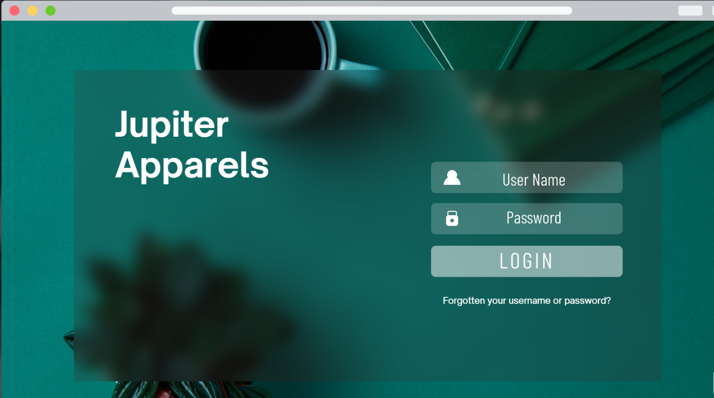

* **Add New User**

Administrators, secondary management users, and HR managers have the authority to create user accounts.

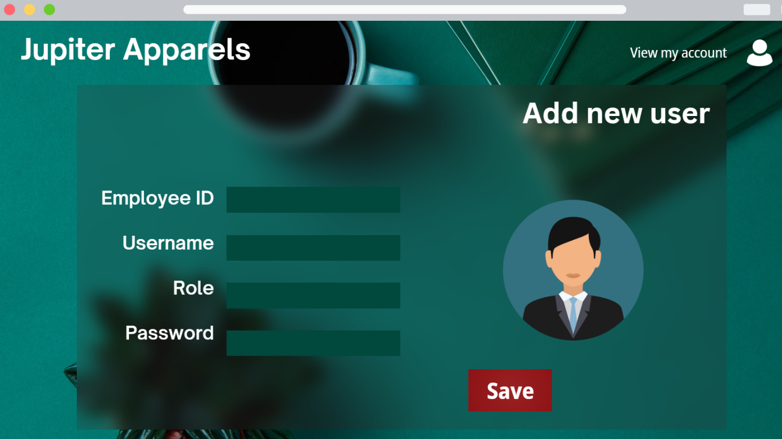

* **View Personal Info.**

Users have the capability to access and review their own profile information.

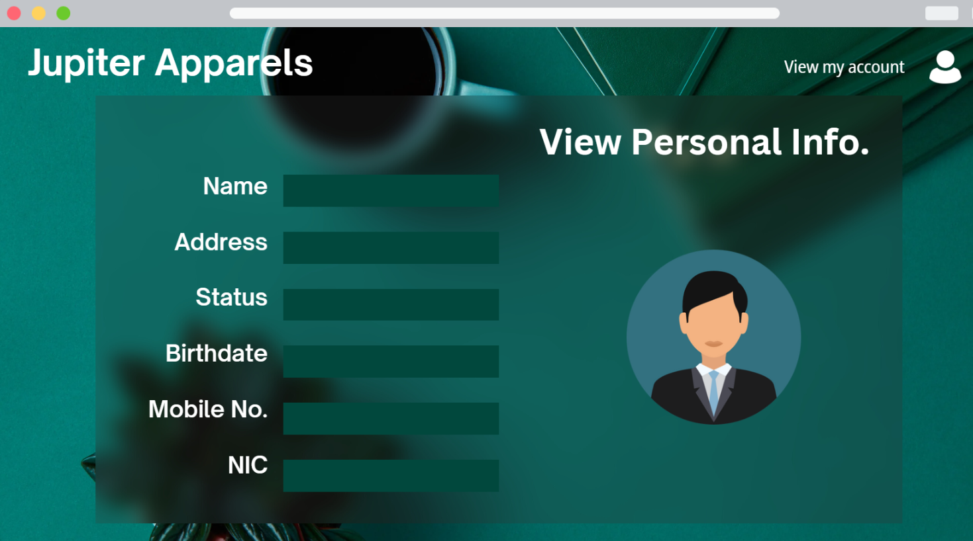

* **Edit Personal Info.**

Users possess the ability to modify or update their profile information as needed.

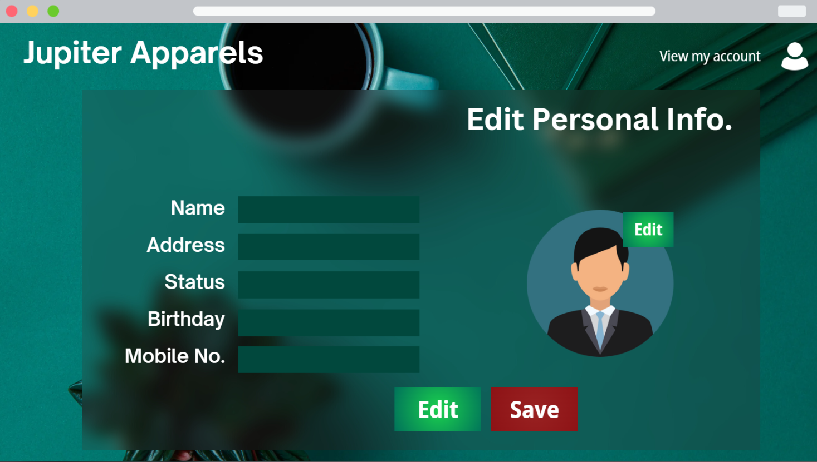

* **Request Leave**

Employees can submit leave requests by completing the designated form.

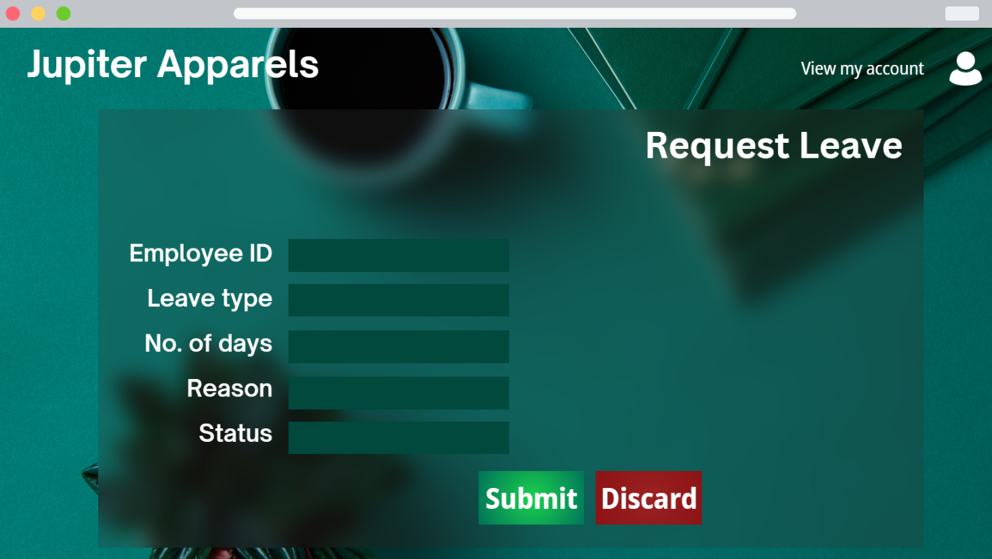

* **Approve/Reject Leave**

Supervisors have the authority to approve or decline the leave requests submitted by employees(subordinates).

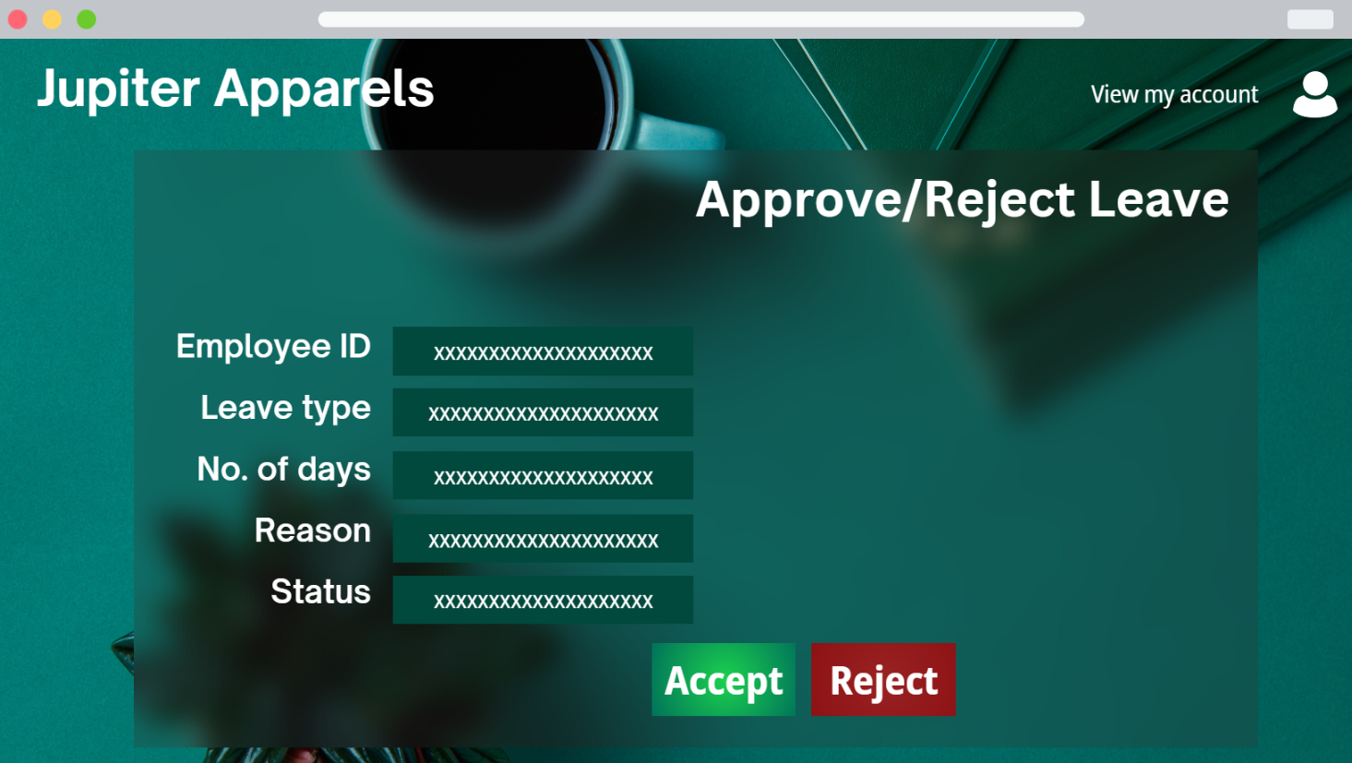

* **Generate Reports**

The system can generate reports as needed.

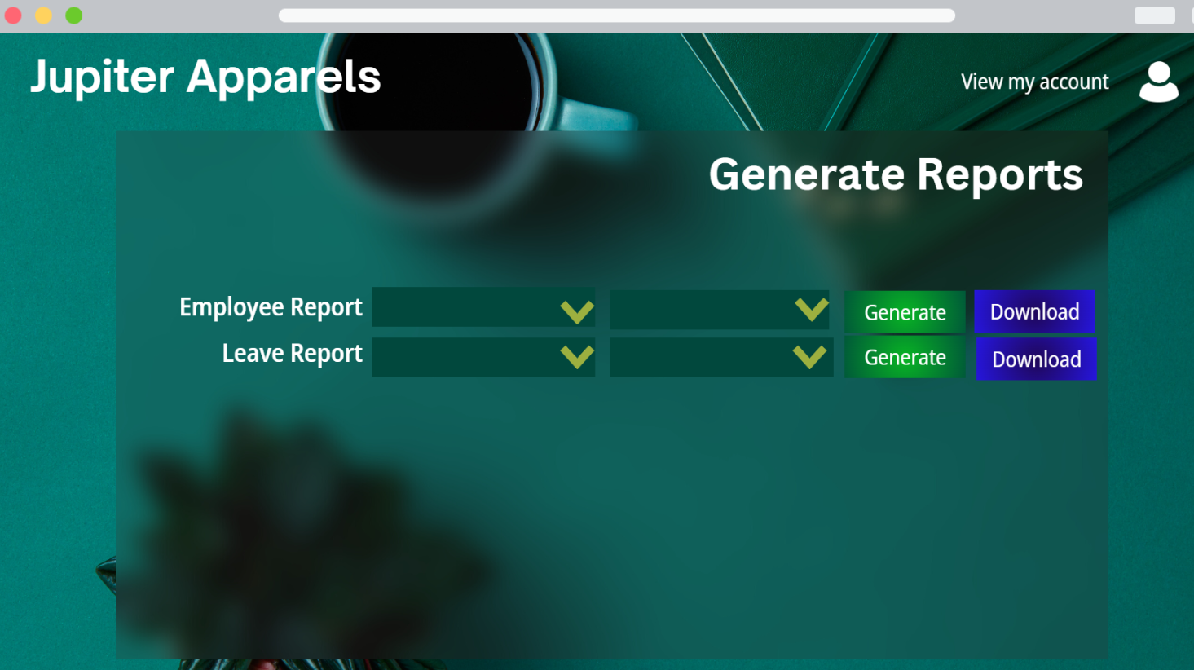

* **Edit Table Attributes**

Administrators have the capability to modify various tables, such as the one containing employee information

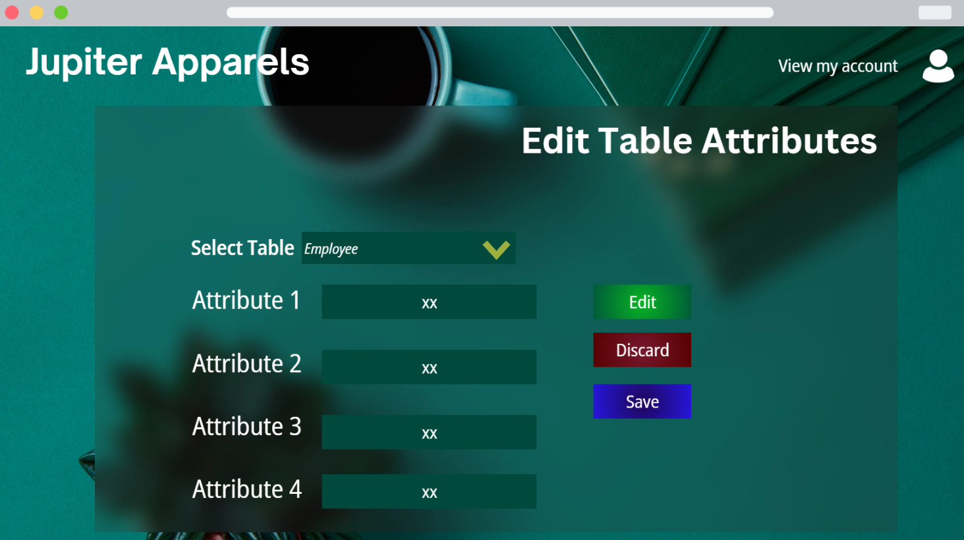

* **Customize Leave Allowances**

Administrators can both access and update the leave quotas for individual employees based on their respective pay grades.

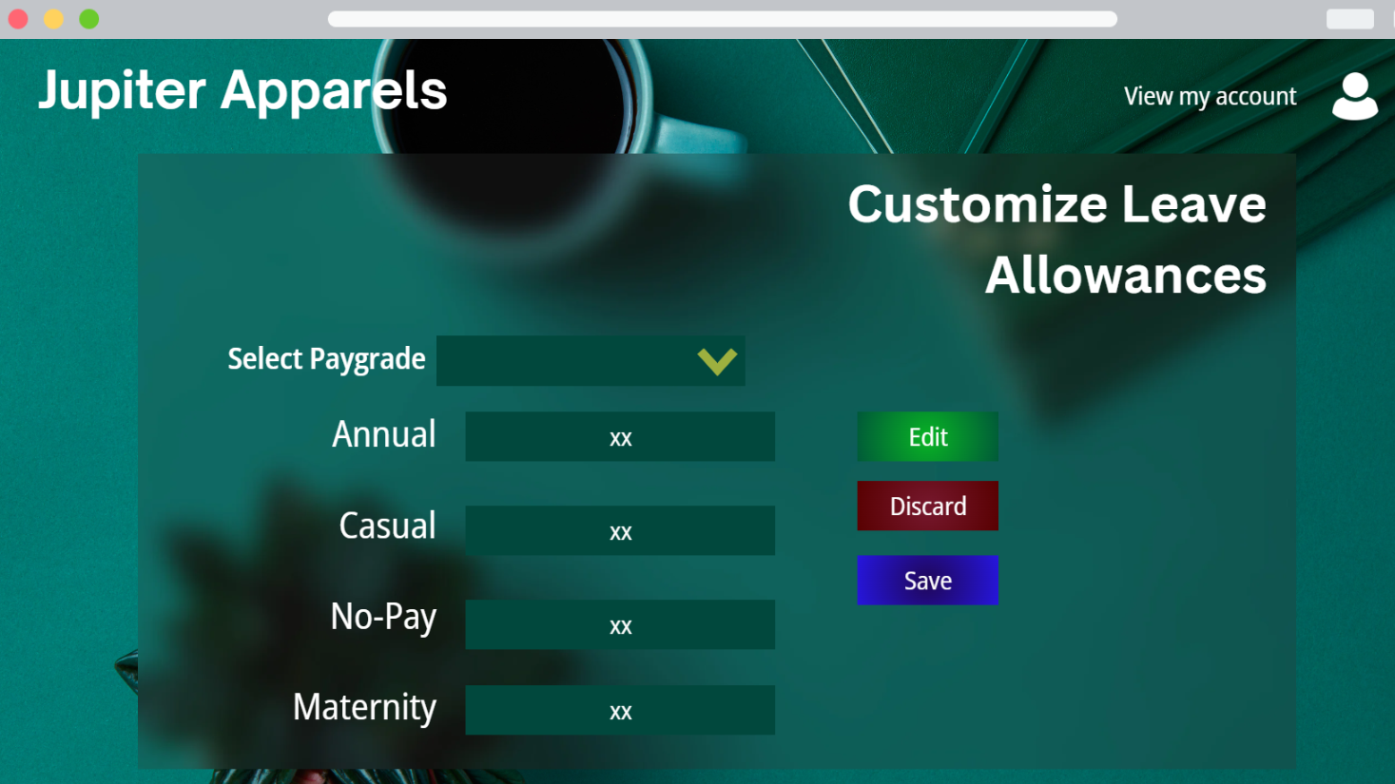

**3.2 Hardware Interfaces**

Server: The software product will be hosted on a robust server machine optimized for efficient database operations and responsive handling of user requests.

Client Devices: Users will access the system via web browsers on a variety of client devices, including desktop computers, laptops, tablets, and smartphones. Our web-based system is designed to be universally accessible, eliminating any hardware restrictions. Additionally, we will provide a mobile-friendly interface to ensure seamless usability on smartphones. While not mandatory, a keyboard may be useful for user interactions, especially during the login process.

To ensure the security of data transmission, we will employ HTTPS encryption for secure communication between client devices and the server.

**3.3 Software Interfaces**

Database Management System: The system relies on a relational database management system (e.g., MySQL) for data storage.

Operating System: The software is designed to run on various operating systems, including Windows, Linux, and macOS.

Web Browsers: The user interfaces are accessible through standard web browsers like Google Chrome, Mozilla Firefox, and Microsoft Edge.

We are going to choose Node.js as the foundational technology for our system's backend. Additionally, we plan to incorporate frameworks such as Express for the backend and React for the frontend. This strategic selection of technologies will empower us to create a robust and responsive system with efficient data handling and user interfaces.

**3.4 Communications Interfaces**

The system involves communication over standard communication protocols:

HTTP/HTTPS: Communication between client devices and the server is carried out using the HTTP/HTTPS protocol.

Email:The system may send email notifications to users, including leave approval notifications.

API Communication: If external integrations are required, APIs will be used for data exchange.

# **System Feat**ures

**4.1 Login**

**4.1.1 Description and Priority:**

This functionality permits a user to access the application by logging in. Users are required to enter their accurate login credentials within the provided space. Upon entering the correct information, users gain access to the application and its functionalities. This feature is regarded as having a top priority.

**4.1.2 Stimulus/Response Sequences:**

The "Login" button on the website initiates the login process. Users are directed to a login page where they must enter their login details (username and password). After clicking the "Login" button, the system validates these details. Depending on the outcome, the system displays either successful access or an error message.

**4.1.3 Functional Requirements:**

REQ_01: Only users with valid login credentials should be allowed to log in.

REQ_02: Develop an authentication mechanism that verifies the accuracy of the provided login credentials (username and password).

**4.2 Create new user**

**4.2.1 Description and Priority:**

This functionality enables authorised users, specifically admin users and HR managers, to add new users to the system. It holds a high priority.

**4.2.2 Stimulus/Response Sequences:**

If the currently logged-in user possesses admin or HR manager privileges, they can navigate to the "Create User" page. Upon clicking the "Create User" option, the system will present the "Create User" page. Subsequently, the user can input the necessary information for the new user and select the "Create" button. The system will then validate the provided details and display the outcome.

**4.2.3 Functional Requirements:**

REQ_01: To add a new user, the user must be an admin or HR manager.

REQ_02: The system should verify the authorization of the authenticated user to access the "Create New User" module.

REQ-03: HR managers/admin can assign a job title, pay grade, and employment status to each employee.

REQ-04: Employees must be associated with one supervisor and can have multiple subordinates. The system shall support the assignment of supervisors.

**4.3 View Personal Information of the Employee**

**4.3.1 Description and Priority:**

This functionality enables users to access their own personal details, and it also grants authorized users the ability to access the personal information of other users. To view the personal information of others, the user needs to hold roles like admin user, second management user, HR manager, or supervisor. This feature is classified as having a relatively lower priority.

**4.3.2 Stimulus/Response Sequences:**

Users can view their personal profile by clicking on the profile logo in the upper right corner of the website. Additionally, authorized users, including admin users, second management users, HR managers, and supervisors, can view other users' profiles by clicking on their name or profile picture. The system checks user authorization to display the requested profile information.

**4.3.3 Functional Requirements:**

REQ_01: To view their personal profile, users must be logged into the system.

REQ_02: The system shall validate the authorization of the authenticated user to access and view other users' profile information, including details such as name, birth date, marital status, and emergency contact information.

REQ_03: In case a user attempts to access another user's personal information without the appropriate authorization, the system should display an error message and restrict access.

REQ_04: For users with the necessary authorization (admin user, second management user, HR manager, or supervisor), the system shall provide a search or filter functionality to efficiently find and access other users' profiles.

**4.4 Edit Personal Information**

**4.4.1 Description and Priority**

This functionality enables a user to modify and update personal information within their profile. It is important to note that a Managerial Employee, HR Manager, Second Management User can only make changes to personal details. This feature holds a medium priority.

**4.4.2 Stimulus/Response Sequences**

To initiate the profile update process, the user begins by clicking on the profile icon located in the upper right corner of the website. Subsequently, they can access the profile update window by selecting the "Edit" button. Within this window, the user can input new data, including any changes to their personal information. To authenticate these updates, the user is required to enter their current password. Upon completing these actions, the user can click on the "Update" button. The system will then proceed to verify the updated user data and provide feedback on the outcome.

**4.4.3 Functional Requirements**

REQ_01: Users must have an active login session to access and modify their profile information.

REQ_02: When a user requests to edit their personal information, the system shall verify the user's identity by prompting them to enter their current password.

REQ_03: In case a user attempts to edit personal information without providing the correct current password, the system shall deny the update request and inform the user of the incorrect authentication.

REQ_04: After editing and updating personal information, the system shall validate and save the changes, ensuring data accuracy and consistency.

REQ_05: The system shall provide feedback to the user upon successful update of personal information, confirming the changes and displaying a confirmation message.

## 4.5 Request Leave

**4.5.1 Description and Priority**

Users can request a leave of absence using this feature. All users have access to this function. All users have access to this feature, but they must fill out and submit a request first. The supervisors are able to assess it and accept/reject it. This feature can be considered as a feature with higher priority.

**4.5.2 Stimulus/Response Sequences**

The user must log in and then click the “Request Leave” option on the homepage. Then the system will show the application page for leave requests. The user completes the application by entering the required data. Next, the system validates the supplied data and makes the supervisors aware of the request.

**4.5.3 Functional Requirements**

REQ-1: The user must have logged into the system to request leave.

## 4.6 Approve/Decline Leave

**4.6.1 Description and Priority**

Administrators can utilize this functionality for reviewing other employees’ leave requests. This feature is available only for supervisors. They can view and approve or reject any leave requests submitted by other employees. This feature can be given a higher priority.

**4.6.2 Stimulus/Response Sequences**

If the user is a supervisor, they can access the “Leave Requests” page from the homepage by clicking the “Leave Requests” button and view all the requests submitted by the employees. The supervisor can then select one of these to view information about the desired leave by clicking on it. Then he can accept or reject the request on that page by selecting the appropriate buttons, which are named “Accept” and “Decline”. After that, the system updates the request’s status.

**4.6.3 Functional Requirements**

REQ-1: The user must have logged into the system.

REQ-2: The user must be a supervisor to approve or decline a leave.

## 4.7 Generate Reports

**4.7.1 Description and Priority**

Using this functionality, a user is allowed to obtain an extensive report on all employees, employees in a particular pay grade, departments, job titles, and leaves. Only second management users and HR managers have access to this capability. This feature can be given a high priority.

**4.7.2 Stimulus/Response Sequences**

If a second management user or HR manager is currently logged in, they can access the “Generate Report” page by clicking the “Generate Report” button on the homepage. The user has some options on that page for generating reports. The system generates a report after the user hits “Generate”, which can be downloaded by clicking “Download”.

**4.7.3 Functional Requirements**

REQ-1: The user must be logged into the system.

REQ-2: The user must be a second management user or HR manager to access this feature.

**4.8 Customize Leave Allowances**

**4.8.1 Description and Priority**

The leave counts for each pay grade can be configured by the user using this feature. Only second management users and HR manager have access to this feature. Each pay grade’s values for annual, casual, maternity, and no-pay can be modified by the user. This feature can be regarded as a medium priority feature.

**4.8.2 Stimulus/Response Sequences**

A second management user or HR manager who has logged in can access the “Configure Leave Allowances” page by clicking on the “Configure Leave Allowances” button on the main page. Then after clicking on the “Edit” button, the user can change the values for the annual, casual, maternity and no-pay leave counts by choosing the pay grade from the drop-down menu. Following that, the system verifies the input values and changes the relevant information.

**4.8.3 Functional Requirements**

REQ-1: The user must be logged into the system.

REQ-2: The user must be a second management user or a HR manager to access this feature.

**4.9 Change Table Attributes**

**4.9.1 Description and Priority**

The admin can edit the tables of the database, especially the employee table by changing, adding, or removing attributes. This will help administrators in the future when defining new custom employee attributes. This feature can be categorized as medium importance.

**4.9.2 Stimulus/Response Sequences**

The "Edit Table" button on the homepage can be clicked by the logged-in user to access the "Edit Table" page when they are an administrator. The system will then display the table information for editing after the user clicks the "Edit" button. After making any necessary changes, the user can click the "Save" button to store the newly modified data. The system then verifies the input values and changes the pertinent data.

**4.9.3 Functional Requirements**

REQ-1: The user must be an admin to access this feature.

# **Other Nonfunctional Requirements**

## **Performance Requirements**

The system's performance requirements prioritize efficiency and responsiveness by minimizing overhead, emphasizing fast loading times in areas with poor network coverage, and ensuring lightweight access, even on older hardware. While cloud storage is recommended for scalability, potential slowdowns underscore the need for balanced design and optimization to harness the cloud's benefits without compromising system performance.

## **Safety Requirements**

Ensuring data consistency during connection losses and server failures is a paramount safety requirement. The system must employ robust mechanisms like transactions, replication, and backups to safeguard data integrity. Furthermore, a monthly maintenance regimen is imperative. It includes updates, security patches, optimization, and health checks, guaranteeing system safety, reliability, and optimal performance.

## **Security Requirements**

The system is made to prevent unauthorized access to any employee information, ensuring strong security measures. Users must meet strict requirements for their username and password, which must be at least 8 characters long, have a combination of numbers,symbols, and include at least one upper case. Access levels are strictly controlled, and employees are only permitted to read their own personal information. In order to protect both the application and the database from common security threats, the adoption of secure cloud services is also required.

## **Software Quality Attributes**

The system must allow for the definition of unique employee attributes, enabling authorized users with the necessary access permissions to add new attributes as required. Additionally, user-friendliness should be given top priority when designing the system, ensuring that employee onboarding and training are simple and effective. This focus on simplicity improves user adoption and improves the overall effectiveness and usability of the system.

## **Business Rules**

To keep data secure and under control, the system includes various data access restrictions based on user types. To preserve their privacy and data security, Level 1 users are only permitted to read their own personal information. On the other hand, managerial staff are given editing rights for all PIM (Personal Information Management) data, enabling them to monitor and change vital personnel data as needed. There are limitations on how new user accounts can be created. The capacity to efficiently manage HR-related tasks is granted to admin users through the authority to create HR manager accounts. In turn, HR managers have the opportunity to add more employee accounts to the system, speeding the user base expansion process and guaranteeing that the user administration of the system stays well-organized and managed.

# **Other Requirements**

**6.1 Database Requirements**

A reliable and scalable database system will be needed for Jupiter Apparels' Human Resource Management System (HRMS). Employee data, payroll details, absence logs, and other HR-related data should all be able to be stored and retrieved from the database with ease. To maintain data security and adherence to privacy laws, it should support data encryption and access controls.

**6.2 Legal Requirements**

All applicable labor laws and rules in the countries where Jupiter Apparels conducts operations must be complied with by the HRMS. To reduce legal risks and ensure the company follows legal requirements, it should have features like automatic compliance checks for labor laws, data privacy laws, and tax laws.

**6.3 Data Backup and Recovery**

To avoid data loss in the event of system malfunctions, mistakes, or security breaches, a reliable data backup and recovery system should be set up location. It is important to perform regular backups and to have thoroughly tested and documented recovery procedures.

**Appendix A: Glossary**

| **Term** | **Definition** |
| --- | --- |
| IEEE | Institute of Electrical and Electronics Engineers |
| SRS | Software Requirement Specification |
| ERP | Enterprise Resource Planning |
| HTTP | HyperText Transfer Protocol |
| API | Application programming interface |
| HTTPS | Hyper transfer protocol secure |
| GUI | Graphic user interface |

**Appendix B: Analysis Models**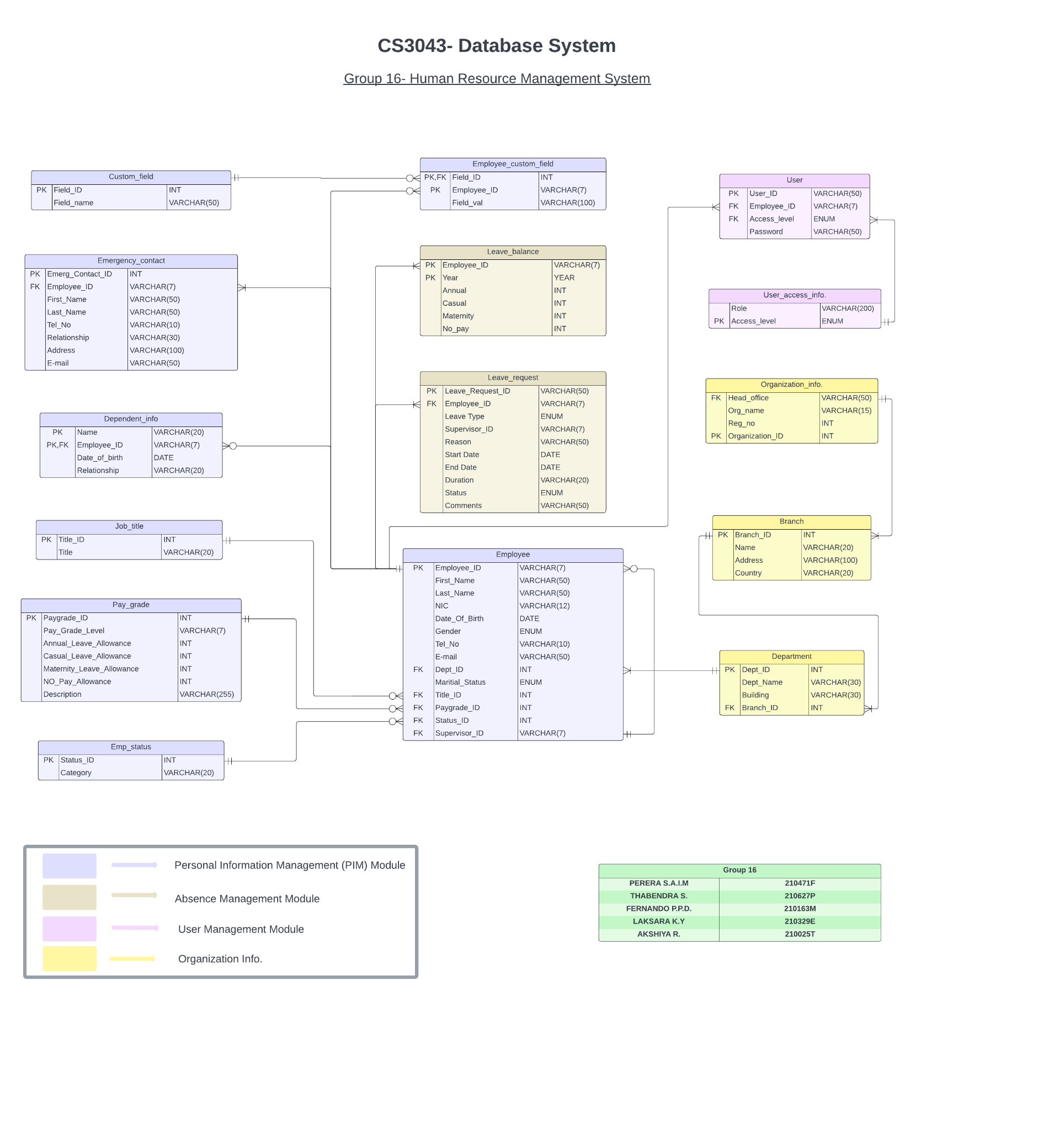

**Use Case Diagram**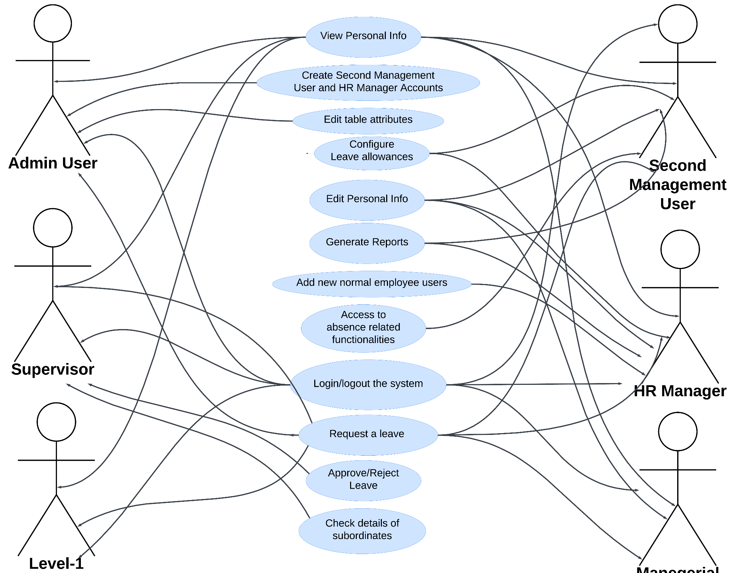

**Employee Managerial Employee**

*-end-*